**CS-4497 / CS-6497 Computational Aesthetics Fall 2019**

Jarek Rossignac

# Goals and overview

GaTech graduates need to be fierce **problem solvers** who seek diversity of ideas, who are comfortable with ambiguity, and who can work effectively across domain boundaries. This course is designed to help them sharpen these skills.

The rationale for accomplishing this by studying **Computational Aesthetics** stems from three arguments:

* 1. Like most people, many of our students seem to experience discomfort with **ambiguity**, with not knowing. It is our duty to prepare them for a life of not knowing. Let us help our students learn from artists and from researchers how ambiguity can be exploited and enjoyed. Let us give them the time to experience the importance and power of curiosity.
  2. Most of our students say that what they want most is opportunities to be **creative**. Yet, we often put a lid on their creativity by providing them with overly detailed problem / project specifications and with ready-to-use mathematical formulae or paradigms that they should apply. We propose instead to help our students become aware of their own potential and limitations by challenging them to try and solve problems that we, ourselves, do not know how to solve. Even better: Let us encourage them to invent their own problems. “Creativity is not following a Lego booklet, but playing with a bucket of legos!” Let them learn and practice new mathematical and computational tools when these are needed in service of ideas.
  3. Most of our life decisions and much of industrial endeavors are guided by **aesthetic** choices about cars, houses, furniture, apparel, watches, music, web pages, etc.. Our graduates must understand the prevalent physical, mathematical, computational, and psychological models of aesthetics, must know how to apply them creatively, and must have the critical thinking abilities and sensitivity to evaluate their effectiveness. To lead the accelerating evolution of industry, GaTech graduate students and researchers must be able to understand the new aesthetic opportunities constantly afforded by new materials, by new design and manufacturing/construction technologies, by smart/connected environments, and by new media and human-computer interfaces. Based on that understanding, they must feel inspired and empowered to keep extending, adapting, and transforming these models of aesthetics.

No single course can accomplish all of these goals. So, the modest objective of this course is simply to expose our students to ambiguity, creativity, and aesthetics and hopefully to give them the desire and momentum to continue exploring them.

Hence, to prepare students for a successful career, the course in **Computational Aesthetics (CAe)** strives to convince them that ambiguity should not be resented, but instead cherished as an opportunity for creativity, and that effective communication requires learning how to listen to—and understand—people from a broad spectrum of interests, expertise, terminology and ways of thinking. Hence, CAe is structured as an inquiry-driven, scientific-modeling course that invites students to listen to what domain experts have to say about aesthetics principles in their domain, based on that knowledge to then invent their own conjectures about beauty, to design and implement a precise computational models that exploit these conjectures to help users beautify various artifacts, and finally to disseminate their conjecture and its merits in a clear and convincing manner, while ensuring scientific accuracy and integrity.

The course is punctuated by series of short team-projects that each focuses on different domain: color, music, shape/pattern, and animation. For each project, students research existing knowhow and listen to (guest) lectures in that application domain. Then, based on what they can synthesize from this exposure, then invent their own measures of beauty, formulate them mathematically, and design and implement algorithms that help users design beautiful artifacts or beautify existing ones. The deliverables of each project include a precise mathematical and/or computational formulation of the proposed measure of beauty, an implementation of an algorithm that strives to beautify input artifacts or to create beautiful artifacts, a demonstration of its merits and of its limitations, and a video presenting the conjecture in a convincing manner, explaining the algorithm with clarity, and discussing its merits. No formal user studies will be conducted to validate these conjectures. In their final project, students will also have the opportunity to investigate aesthetic principles in a broad spectrum of application domains, including photography, painting, web design, interior design, fashion, industrial design, architecture, music, cinema, and dance.

The projects will provide the motivation for learning and applying a variety of concepts, such as logarithmic scales and spirals, regular series of geometric transformations, measures of similarity and of regularity, and continuity measures of shapes or motions.

Implementation will require designing algorithms that manipulate graphs or arrays of points, pixels, polygons, transformations, colors, beats, or musical notes.

Although some of the models of beauty discussed in this course are based on accepted artistic principles and on principles of human perception, there are no expectation that students have any expertise in these, nor that they have any artistic talent or aptitude.

However, students must have taken a graphics course or have demonstrated proficiency what it teaches.

We anticipate that, as in the past two offering, the course will host guest lectures by experts in application areas and presentation by teams of students. The objective of the course is not to suggest that art can be mechanized or reduced to a few equations. Quite the contrary: students will have a chance to explore and discuss the nature and importance of beauty, its manifestations in art, the structure of the aesthetic design space, and new possibilities of design choices available to artists and designers.

# Readings

At this time, there is no adequate textbook on Computational Aesthetics. However, there is an international conference fully dedicated to Computational Aesthetics and a growing number of scientific papers are published every year in top tier journals and conferences in the fields of Computer Graphics, Image Processing, and Machine Learning, and also in the specific artistic fields, such as computer-assisted music analysis and composition. Here are examples of articles used in the past:

**Cluster-based color space optimizations**, International Conference on Computer Vision (2011)

**Probabilistic Color-by-Numbers: Suggesting Pattern Colorizations Using Factor Graphs,** ACM Transactions on Graphics (2013)

**The Philosophy of Music**, Stanford Encyclopedia of Philosophy (2017)

***Geometry and Harmony****, Mathematical Connections in Art, Music, and Science (2005)*

**The distance geometry of music**, Computational Geometry (2009)

**A Geometric Property of the Octatonic Scale***,* International Mathematical Forum (2007)

**Auditory Perception**, Stanford Encyclopedia of Philosophy (2014)

**Geometric Hermite interpolation by logarithmic arc splines**, Computer-Aided Geometric Design (2014)

**Log-Aesthetic Magnetic Curves and Their Application for CAD Systems**, Mathematical Problems in Engineering (2014)

**The Philosophy of Dance**, Stanford Encyclopedia of Philosophy (2015)

**Evaluating the … Attractiveness of Human Motions on Realistic Virtual Bodies,** ACM Transactions on Graphics (2013)

**Suggestive Contours for Conveying Shape**, ACM Transactions on Graphics (2003)

**Principles of traditional animation applied to 3D computer animation**, Computer Graphics (1987)

**Processing Fluency and Aesthetic Pleasure: Is Beauty in the Perceiver’s Processing Experience?** Personality and Social Psychology Review (2004)

Furthermore, students will be asked to watch instructional or demonstration videos on different aspects of Computational Aesthetics or on specific topics in visual arts, music, color, shape, pattern design, and feature animation. Here are a few examples:

What is up with Noises? (The Science & Mathematics of Sound, Frequency, and Pitch) https://[www.youtube.com/watch?v=i_0DXxNeaQ0](http://www.youtube.com/watch?v=i_0DXxNeaQ0) How Basic Chords Work - Music Theory Lesson 1, https://[www.youtube.com/watch?v=5Y01jIorpeA&t=389s](http://www.youtube.com/watch?v=5Y01jIorpeA&amp;t=389s)

Bernstein on Schoenberg, https://[www.youtube.com/watch?v=olwVvbWd-tg](http://www.youtube.com/watch?v=olwVvbWd-tg)

# Grading

The final grade combines the following components with these weights: Programming projects with written report and video: 60% Written exam: 20%

Active class participation: 20% (graded homework 10%, in-class exercises collected and graded 10%)

# Prerequisites

Pre-requisites for *CS4803-CA: CS3451 - Computer Graphics, which is a required course for the Media thread*

Pre-requisites for *CS8803-CA:* CS6491 *- Computer Graphics*

# Learning objectives and educational outcomes

The strength of Georgia Tech students is their ability to build accurate models in a variety of disciplines or application domains and to automate the analysis and improvement of these models. But to be able to exercise this strength, students need to be able to transcend the communication barrier between precise mathematical/algorithmic thinking and the more abstract concepts and vocabulary used in many application domains. Hence, they need to develop and practice skills for listening, understanding, inventing, and validating.

Furthermore, they need to know how to adhere to a rigorous scientific methodology while inventing and validating such models.

The main learning objective of this course is to help students develop and reinforce these skills. This will be done through a series of projects in a variety of application areas. Each project will follow the same steps:

1. Understand the theories or principles that domain experts have formulated in their own language
2. Develop a crisp mathematical model that captures some of these principles or proposed variations
3. Learn the mathematical, geometric, and algorithmic tools needed to implement that model
4. Implement it, debug it, and provide an easy to use interface for demonstrating it
5. Test it informally and reflect on its merits and shortcomings
6. Write a clear report describing the model, the proposed conjecture, and the informal conclusions

Student will learn:

1. How to understand abstract, and often ill-formed, concepts and principles in a various application domains,
2. How to translate them into mathematically precise formulations,
3. How to invent an intuitive (geometric or metaphorical) interpretation of these formulations,
4. How to design and test algorithmic implementations that exercise these formulations,
5. How to integrate these implementation into interactive tools that appear intuitive to users in a specific domain
6. How to validate the correctness or benefits of these formulations
7. How to write clear conclusion without making any statements that are not scientifically justified

# Academic integrity

Some programming projects will be individual. Other will offer the option to work in a team of two. Everyone student/team submit their own work, and you may not share code or answers with others. For team projects, each team members will present her/his contribution in class and/or on the submitted video.

Students are encouraged to form study groups and to discuss the problem sets and readings outside of class. If your discussion with another student helped you make a breakthrough on a difficult problem, that is fine, but be conscientious and thorough: always give credit!

Similarly, if you found a paper or code that helps you with part of your assignment, that is great—provided that you acknowledge the source clearly and include in your report a detailed explanation of it that demonstrates your understanding of it.

Suspected cases of honor code violations will be handled through the Office of Student Integrity. If you have a question about collaboration policy, please ask.

# Learning accommodations

If needed, we will make classroom accommodations for students with documented disabilities. These accommodations must be arranged in advance and in accordance with the Office of Disability Services (http://disabilityservices.gatech.edu).

# Projects

The course will involve 4 research and programming projects. Each project will require: (1) Understanding key concepts and guiding principles in a given field (such as styling, color composition, music composition, animation design, photograph composition, pattern design), (2) Inventing a computational model for measuring and/or the beauty of an artifact, (3) Providing a convincing argument that the invention merits to be investigated, (4) Implementing it, (5) Performing an informal validation, (6) Providing an honest evaluation of its merits and shortcomings, and (7) Suggesting further research. The deliverables include the source code, a report, a video explaining and demonstrating the approach, and (for some projects) a short presentation in class. Here are examples of projects for the first two offerings:

(1) Calculate a visually pleasing color ramp that is easy to learn and read, (2) Compute a pleasing musical transition between the given start and end of a melody, (3) Transition smoothly between two given techno-rhythms, (4) Compute a pleasing animation of a simple creature walking between two given frames and conveying a specific emotion (joy, sadness, fear…), (4) Develop an interactive tool for designing shape and color animations that are synchronized with music, (5) Develop a tool for creating and animating logarithmic spiral patterns.

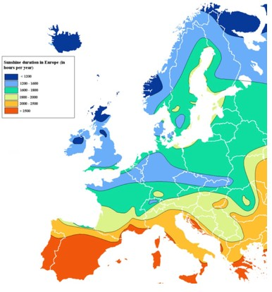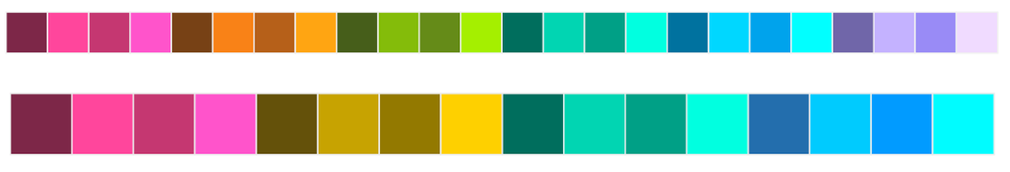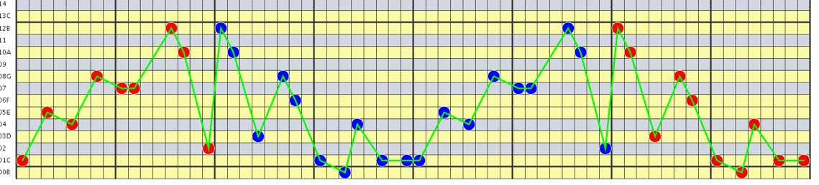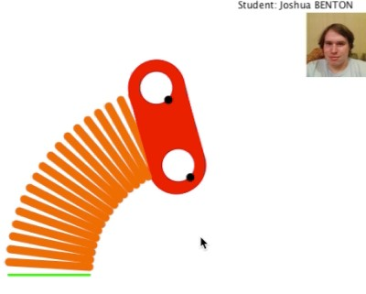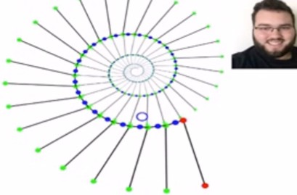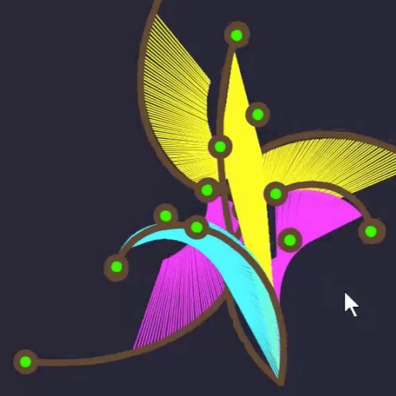

# Outline of topics

The course is divided into modules, each one focused on a different application domain. The lectures will alternate between lectures devoted to the specific technical concepts (math, geometry, algorithmic, graphic, animation) that may be needed for a particular project and lectures devoted to a general discussions of the broader context of Computational Aesthetics or to exposing students to application areas, which may include instructional videos, Guest Speakers (artists, researchers), and attending presentations by other students.

## Importance of aesthetics in Industry, Society, and Life

Via readings, discussions, and Guest Speakers, students will learn the importance of aesthetics in our lives and in our economy. For example, they will discuss statements that claim that 85% of consumer view **color** as the primary reason for deciding to buy a particular product, that 93% look at visual appearance of the product, and that 80% think that color increases brand recognition. Students will investigate the huge importance of **shape** aesthetics when purchasing a pair of shoes, a dress, a chair, a car, or a house. They will be invited to appreciate the need for precise **metrics** of aesthetics and for computational tools that guide or assist designers in creating pleasing sounds, shapes, patterns, color arrangements, or images, videos, buildings, or neighborhoods.



## Importance of objective measures and beautification algorithms

Through selected papers and video lectures, the students will learn about several philosophical perspectives on aesthetics, on its fundamental role in our culture, and on its **objective** nature. This exposure will provide the platform for discussions about the objectives of the course, about the subjectivity of aesthetics experiences, and about the ambition of developing computational models of measures of beauty or of beautification procedures. The students will be asked to produce short statements summarizing the various philosophical perspectives discussed and expressing their own opinions and ambition for what they hope to accomplish in this field.

## Artists as researchers of aesthetic foundations

Many artists (Picasso, Matisse, Moore, Keane, Schoenberg, Xenakis, Coltrane, Gaudi, and Calatrava…) serve as inspiring role models of tenacious and bold researchers who question the status quo and relentlessly experiment with new models of what is essential in a shape, color arrangement, painting, or musical structure. We will look at such examples to illustrate the opportunities, to point out the tremendous advantage that contemporary computing power gives our students, and to encourage them to be bold in their explorations.

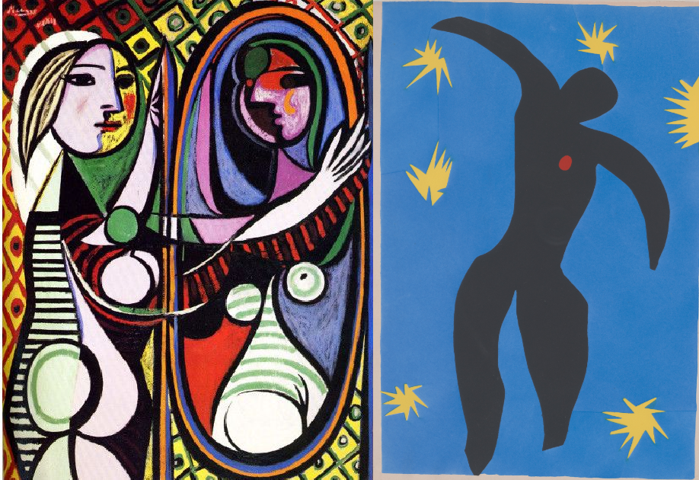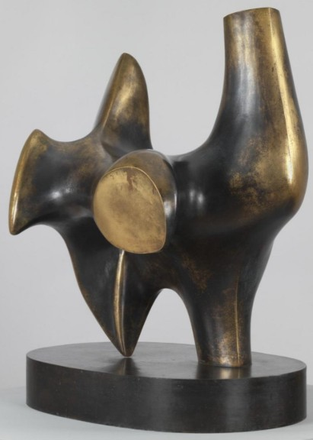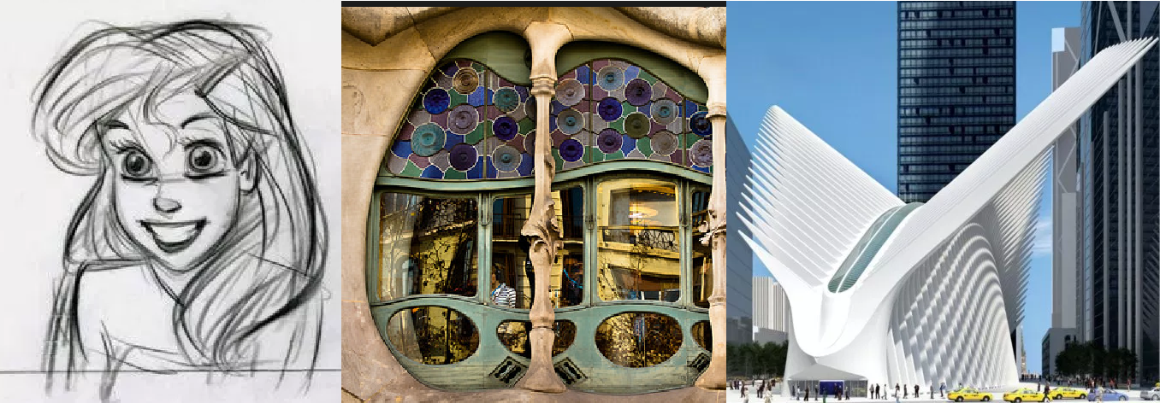

## Morphing, Motions and Patterns

Patterns, where a shape is repeated exactly or with a slight, yet regular, modification are common in nature, in architecture, in manufacturing, and in art. The course will discuss what is known about the perception of motion (including illusions of motions) and will teach mathematical formulations and algorithmic tools for measuring and for increasing the regularity of motions and patterns. One such tool is the Steady Affine Motion (SAM), which is defined by the **equation of beautiful motions**, At=At, where A is a matrix that defines an affine transformation and where t denotes time.

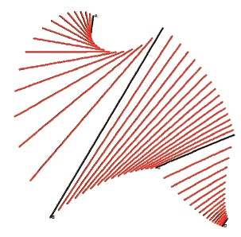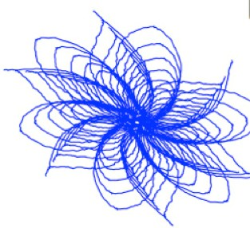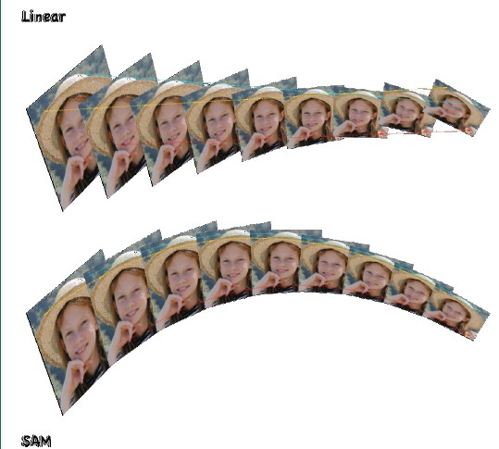

Geometric interpolation is a fundamental tool for defining computational models of curves, motions, patterns, surfaces, morphs and other animations. It also is fundamental for formulating perception-based models of color ramps and music scales. Students will be reminded of arithmetic and geometric progressions, will learn about linear interpolation and constant velocity motion between points, will learn about the pitfalls of linear and spherical interpolations between vectors, and will discover the wonderful properties of logarithmic spiral (“spira mirabilis”) interpolations. The students will learn algorithms that construct such spirals discussion about which patterns that we can observe in nature are beautiful, why, and how they influence art. It will also seed a discussion of simplicity and regularity measures that will be used as key ingredients in defining a measure of beauty later in the course.

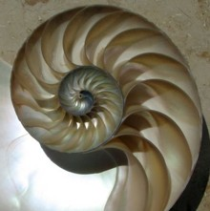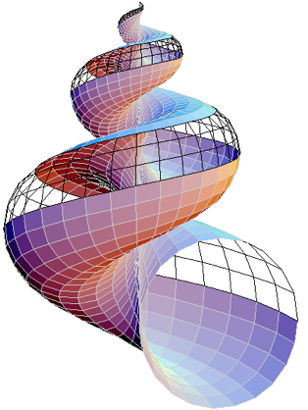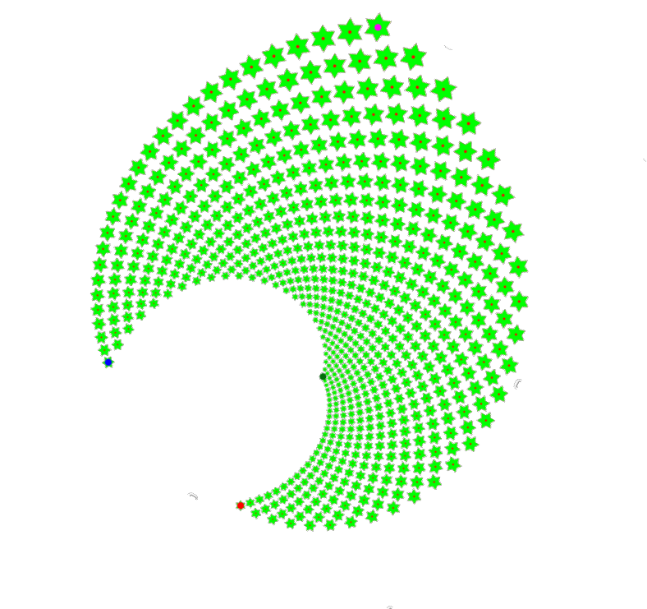

## Color

A vast amount of research and industrial engineering has been invested into the development of an accurate model of how humans perceive colors, and more precisely the distances (measures of perceived differences) between pairs of colors. These models of non-linear distance measures have been used to define color spaces. The course will teach the most popular of these spaces, including the Lab and Lch models of the CIEL, and will explore linear and spiral interpolations in these spaces. We will discuss mathematical formulations of precise measures of the merit/beauty of a color ramp or color scheme for applications that include information visualization, web-site design, clothing, or interior decoration. The students will be asked to invent mathematical formulations and algorithms that generate effective and aesthetically pleasing color ramps or schemes for specific applications. They will be asked to provide informal evaluations of their solutions in the context of prior art.



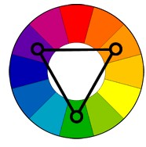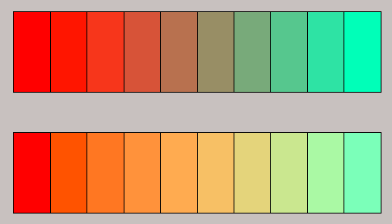

## Music

The course will explore measures and formulations of beauty in harmonies, melodies, and rhythms. It will compare logarithmic and just scales in music and to color interpolation schemes discussed above and will discuss appearance emotionalism and recent findings that link colors and sounds to emotions. One project will involve inventing an algorithm that fills in a few measures of a short melody or that morphs between two Techno rhythms. More advanced projects options for Graduate students will be available, including composition using poly-rhythms and the use of other than the standard tempered 12-tone scale.

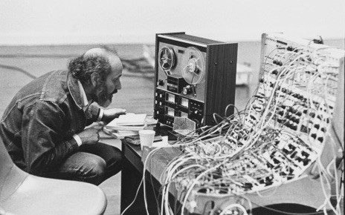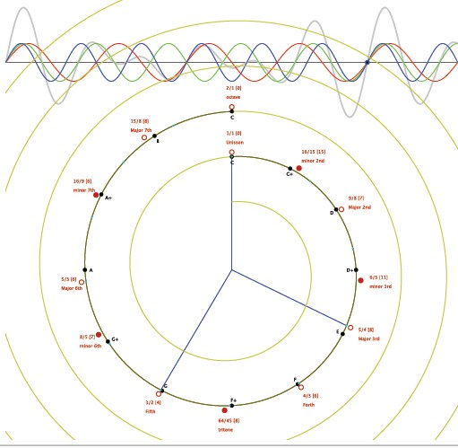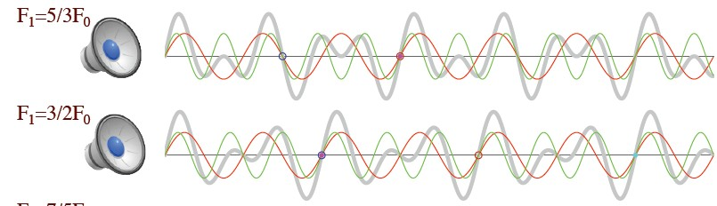

## Shape

The course will discuss several representations of smooth shapes, including curve-subdivision based on logarithmic spirals, and analytical / geometric tools or measuring various local or global properties. Armed with these tools, we will examine previously proposed models for measuring the beauty of simple shapes, such as curves or vases, including Birkhoff’s model defining beauty as the ratio of order to complexity. We will explore precise geometric formulations for these terms, including using logarithmic spirals to measure order and morphological measures (formulated in terms of closing, opening, medial-axis transform, or local feature-size) of complexity. We will also explore novel measures of simplicity and complexity that are only perceived when the viewer is moving around a three-dimensional object. We will formulate these measures using the suggestive contours. In a typical projects, students might be asked to invent and implement a shape beautification algorithm for the silhouette of a vase and to explore its aesthetics benefits.

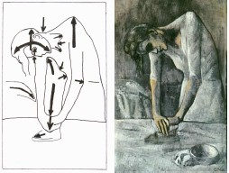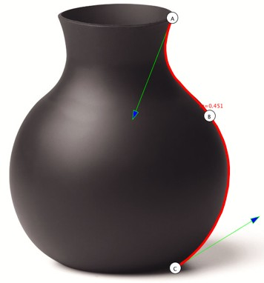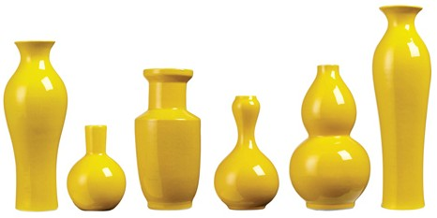

## Paintings, drawings, animation

Painting, illustration, and photograph/video processing techniques may have very different objectives, ranging from clarity and understanding to priming the viewer with specific emotions, to pleasing the eye or intriguing the viewer. The course will discuss examples of image processing techniques, of non-photorealistic rendering (using silhouettes and suggestive contours), of caricatures, and of hand drawn animations and will explore the associated aesthetics principles and challenges.

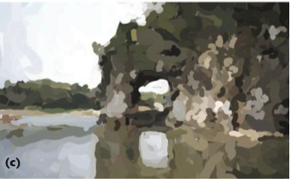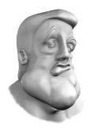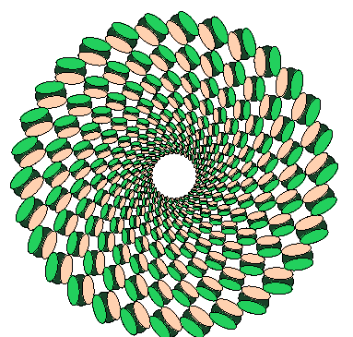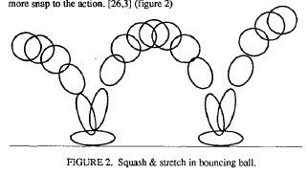

## Photography and Film

Lists of useful rules have been disseminated that codify pleasing or interesting compositions in photographs or in movie shots or transitions. Many of these have simple models that involve geometric constructions, measures of motions, and comparisons of colors. Many of these can be formulated precisely in terms of Computational Aesthetic constructs. The course will discuss the implementations of some of such measures and of beautification procedures based on them. Some of these will be the subject of projects.

We will also discuss advances in Machine Learning of artistic styles and in its use for artistic image synthesis.

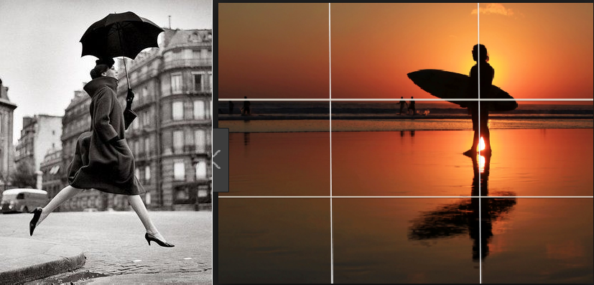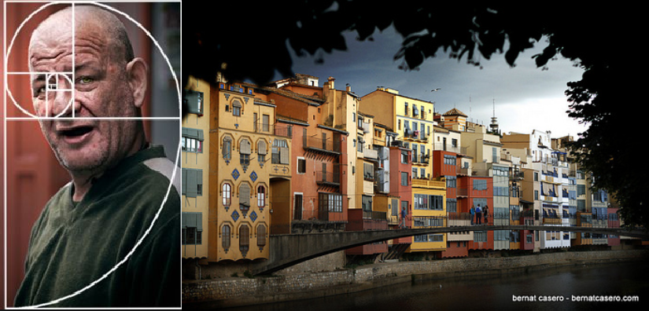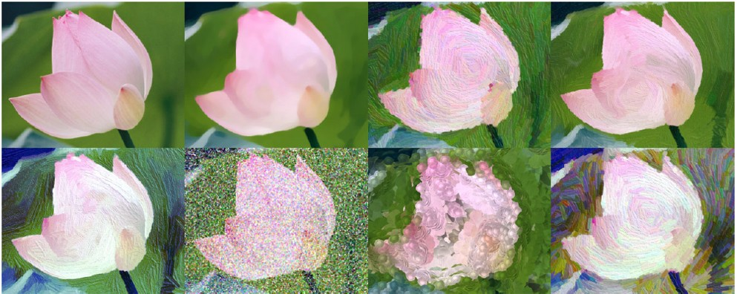

# 10 Additional requirement for Graduate Students

Through additional requirement or extensions, graduate students will be challenged to use, in their projects, more advanced mathematical and programming constructs than the undergraduate students and to invent and evaluate more ambitious formulations.

For example, in the music project, undergraduate students may solve the melody interpolation challenge by codifying and applying a few rules of harmony and composition. Graduate students are expected to build more elaborate, global models to the piece and to write software that analyzes the given music segments and that measures and model their differences. Then, they will define and implement a morphing paradigm and explore melody optimization based on it. Graduate students will also be asked to read additional papers and to provide more thorough explanations and justifications for their approaches.

In the animation project, graduate students will be asked to create an articulated character with more degrees of freedom and to produce software that seamlessly interpolates a series of keyframes, rather than just the start and end key-frames that the undergraduates will focus on.

To enable a clear distinction between graduate and undergraduate students, we will avoid mixed (Grad and undergrad) teams for projects and will grade graduate and undergraduate students differently.

Finally, graduate students will have additional questions in their written exam.

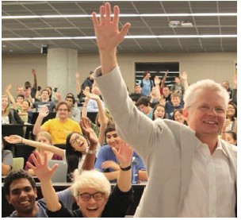

**Schedule of lecture with topics and guests for Fall 2017**

We had 10 guest speakers on topics including using color for interior design of office spaces, the principles of composing and improvising techno dance music, music composition, the computation of stead motions, dance principles from the perspective of a choreographer, aesthetics in architecture, the artistic intention in visual arts, aesthetics in games, design principles for web applications and experiences, and machine learning of artistic styles.

